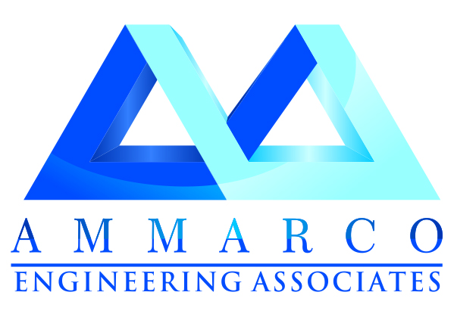
Quality and Durability wrapped in a combination of Archetypal Contemporary designs – brought to you through exemplary professionalism.

Who we are!
Ammarco is only one of its kinds, sole entity having its associated network in Islamabad, established and registered with Government of Pakistan.
Ammarco gratifies itself in bringing in its professional services for interior & exterior design consultancy, planning and execution of business & residential projects. Equipped with specialized and experienced team of technical staff; Engineers, Sub Engineers, Electricians, Plumbers, Painters, Masons and Labor.
Objectives
- To be the strategic associate of our valued customers.
- To provide value added services for the most feasible, cost effective and profitable projects.
- Bring in widespread resources to each project.
- To go the extra mile to ensure clients’ satisfaction – every time!

Interior & Exterior Design
Ammarco is a contracting firm in this business, our Executive and Technical Experts have already handled a vast range of Projects including, Group housings of public sector, Schools, Hotels, Industrial and Commercial buildings etc. Resulting in requisite experience for execution of all types of works. Equipped by sufficient tools, plants and workforce to cater the projects. We are financially sound and enjoy the good support of Leading Manufacturers and Dealers in the respective trade.
We provide the best price sensitive and quality oriented services using dedication as our tool to ensure quality.

Interior Design Services
Ammarco deems that interior of your Premises should manifest an expression as your signature. The spaces we design profess your personality, class, taste and grandeur.

Exterior Design Services
We are providing appropriate services rendered by a team of adroit professionals in order to guarantee the fabulous impression of your facade.

Civil Works
Ammarco is actively engaged in Civil Construction Works for our valuable clients. These services are rendered by our team of skilled and qualified engineers. We use superior grade materials and latest technology machines while rendering these services. Our quality controllers supervise the entire process in order to ensure the first class quality. We offer construction of modern & institutional buildings, hospitals, parking areas, malls, celebration & event halls and so on..

Electrical Works
Electrical fitting services that we offer to various commercial and residential sectors are provided according to clients’ projects’ requirement. We use excellent quality electrical fitting materials & items that are procured from authorized and quality driven vendors. Services are offered after complete planning and designing of working modules.
Plumbing Services
Plumbing services that Ammarco offers to our esteemed clients include various kinds of sewer and drainage pipe fittings and setting up septic tanks, manholes and many more. Operational inspection of undertaken projects before handover with complete satisfaction..

HVAC

Firefighting & Panic Alarms

CCTV

Security Alarms

Solar Panels

Generators & UPS

Data and Voice Networking

Distribution Switchgears & Control Panels

Communication Racks/ Data Cabinets

Eligibility Responses:

It is hereby certified that M/s Ammarco Engineering Associates;
- Is a registered firm.
- Is not bankrupt or in the process of going bankrupt.
- Has not been convicted for any offense concerning professional conduct.
- Has not been guilty of grave professional misconduct (proven by any means which the contracting authorities can justify).
- Has fulfilled obligations related to payment of taxes.
- Is not guilty of serious misinterpretation in supplying information.
- Is not in situations of conflict of interest (with prior relationship to project or family or business relationship to parties.
- Was not declared at serious fault of implementation owing to a breach of their contractual obligations.
- Is not on any list of sanctioned parties issued by the Pakistan Government, United States Government, European Union and United Nations.

Sign and Official Stamp

 | SUPPLIERS’ INFORMATION SHEET (Confidential)
 | Suppliers’ Basic Information:
Full legal and Trading Name. |  | Ammarco Engineering Associates
Date of Registration of company. |  | October, 2014
Complete Address. |  | 1st Floor, Office # 10, Laraib Centre, G-9 Markaz, Islamabad.
Registered place of business. |  | Same as above
Name the contact within our organization to whom all correspondence regarding this quotation should be addressed. |  | Mr. Ammar Mahdi  Phone # + 92 51 2325443  Cell# + 92 333 5766744  ammarco.pk@gmail.com
Company website address. |  | www.ammarco.pk
Name and position of the person authorize to enter into negotiation and sign any formal agreement. |  | Mr. Ammar Mahdi  Phone # + 92 51 2325443  Cell# + 92 333 5766744  ammarco.pk@gmail.com
Company registration details such as  - NTN  - PEC Registration Number. |  | - 4301648-7  - 60357
Name of other key contacts:  Director/s.  Technical Support. |  | Mr. Imran Haider  Director Technical  Cell #: +92-332-9626792  ammarco.pk@gmail.com

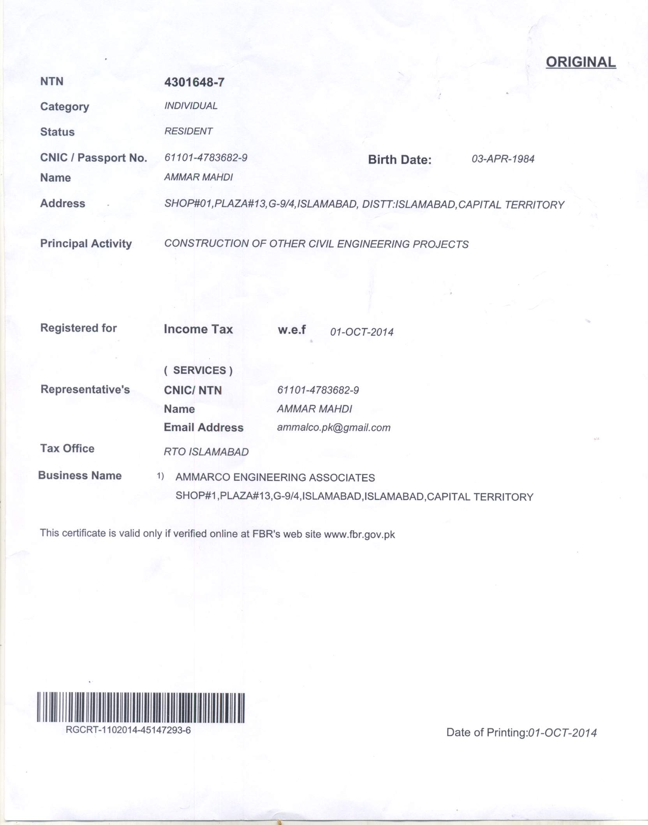

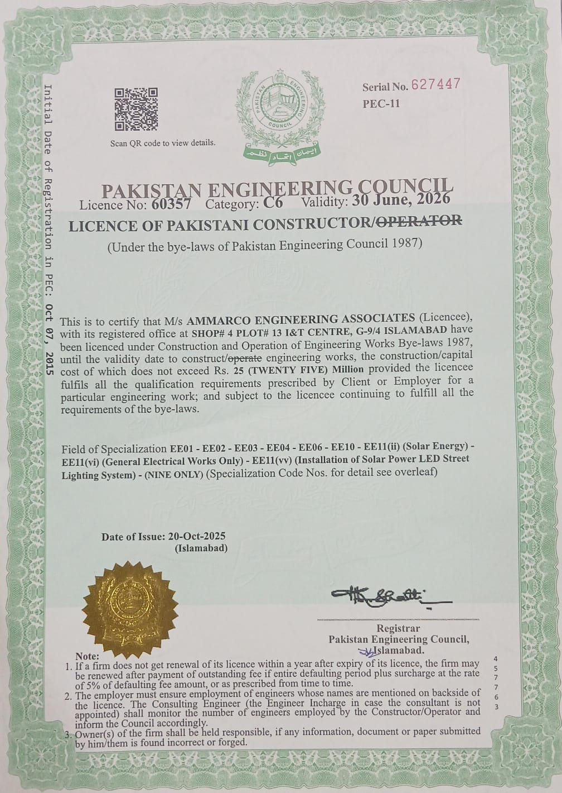

Products & Services:

List of Construction Equipment & Machinery

Chain pulley blocks 10 tons 01 No’s

Chain pulley blocks 05 tons 02 No’s

Tripod stand 02 No’s

COMPACTORS

Plates type 04 No’s

Jumping jack (Mikasa make) 02 No’s

Water Pumps

Centrifugal pump with 10 hp electrical motor 04 No’s

Vertical dewatering set 05 No’s

Latrines empty kits 01 No’s

Submersible pumps 4 hp 02 No’s

Water bladders (30 m3) 02 No’s

Donkey pump with electric motor 05 No’s

Donkey pump with petrol engine 03 No’s

CUSTOMERS EXPECTATIONS

Our customers expect from us and we deliver:

- Long-term partnership
- Listening to their requirements
- Total commitment to Business goals
- Meticulous project management
- Creative solutions
- Stringent budget controls
- Quality without compromise
- On time delivery
- Customer support
- Comprehensive documentation
- Completeness
- Sincerity

Quality Control

- We are not only concerned but bound to maintain strict quality control for our Productsand Results, which are always verified and endorsed by Independent Quality Testing and Documentations, both at our end and Clients end.
- Ammarco Engineering Associates’ Works are strictly monitored by Independent Quality Control System, headed by Independent QC Manager reporting directly to the Managing Partner of the Company.
- At Ammarco, not only the end product goes through a series of quality checks before leaving the works to the Client. But a proper record of raw materials and all stage production quality testing is also maintained, accessible to all the clients at any stage of Production.

What we have
- In house highly equipped Fabrication facility
- Technical Know How
- Professional Management
- Financial backup
- Contacts, Associates and reorganization with in Departments

What we are looking for

- Association with worldwide recognized Organizations.
- Technical and Design support.
- Common business interests in Pakistan and Neighboring countries.

Capability Statement:

Ammarco Engineering Associates is a young multi-disciplinary enterprise based in Islamabad. Our designs draw onboard perception of inspired ideas and innovative problem solving, cultivated through the multi-cultural setting within our offices. The end result is vibrant, energetic and original architectural solutions that explore the juxtaposition of modern architecture, nature and traditional designs.

We bring together extensive capabilities and resources to each project, not just through its talented and experienced professionals but also as a strategic partner to our clients. We implement unique principal in- charge of concepts providing high level of executive input and oversight to all projects.
 | List of major clients | - HBL (Currently Working)  - USAID  - DAI KPG Project Islamabad  - Naklah Supplies ®  - IKAN Engineering Services (Pvt.Ltd)  - Face Impact  - Torque Engineering Services  - FR Constructions  - Vector Engineering Services  - High Rise Engineering Services Pvt.Ltd  - Octagon Engineering
 | Details of our company’s experience in the similar services, keeping in view the following points:  - Name of company/INGOs  - Contract value  - References | Please see the attached P.Os

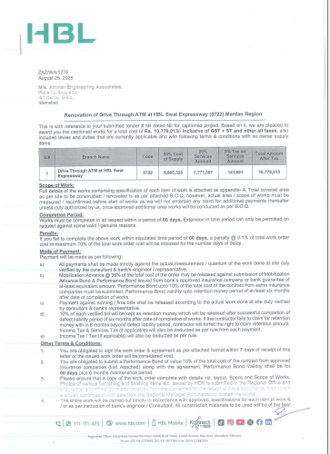

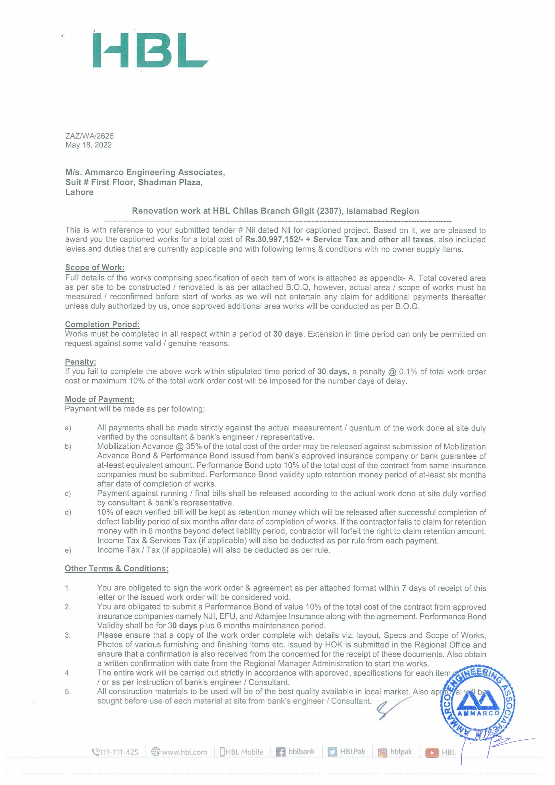
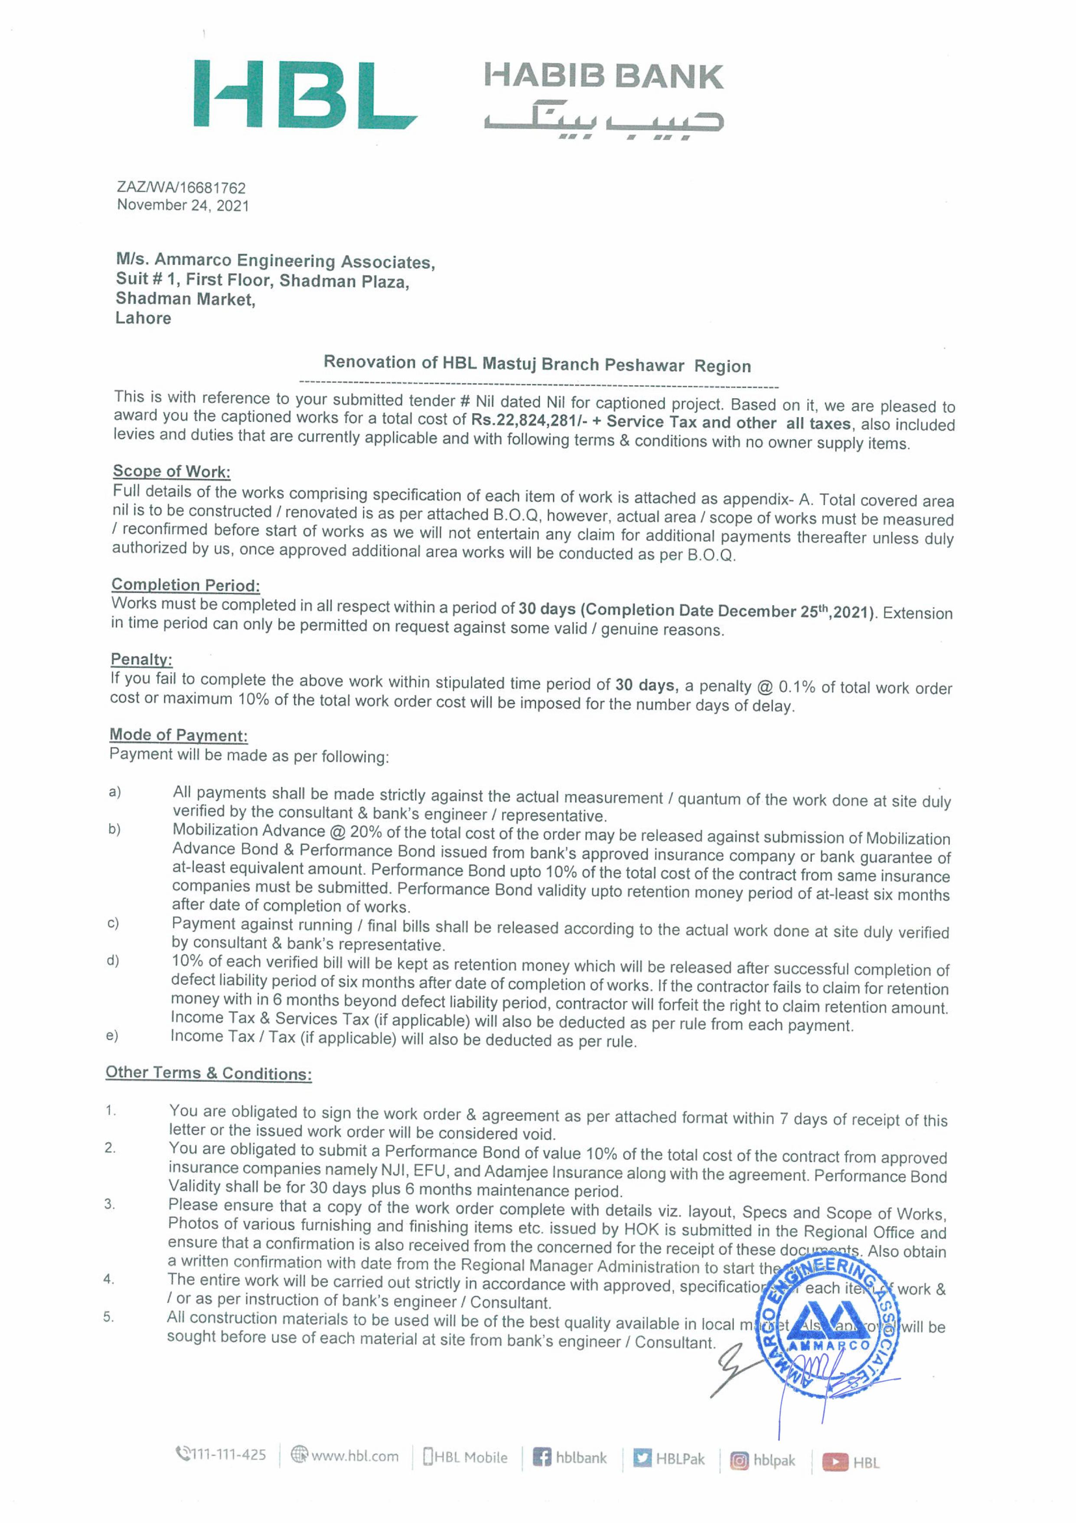
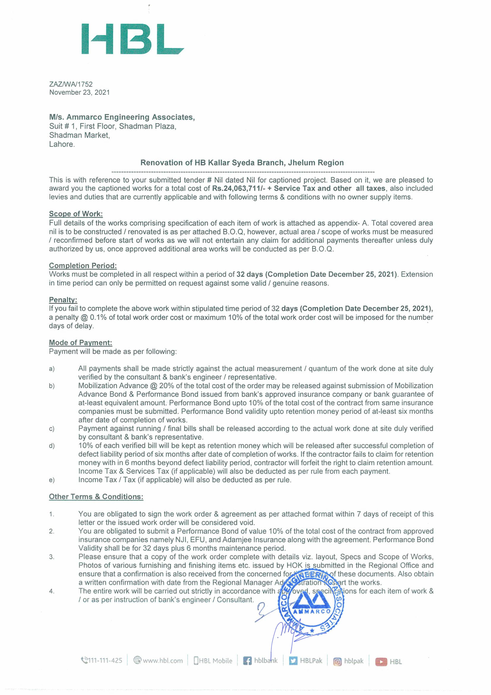
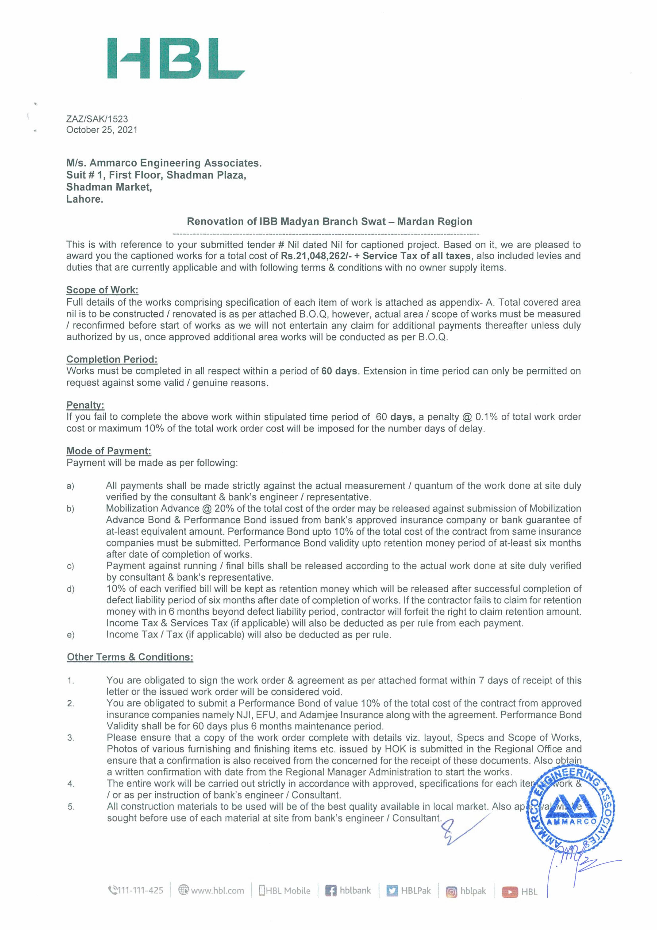
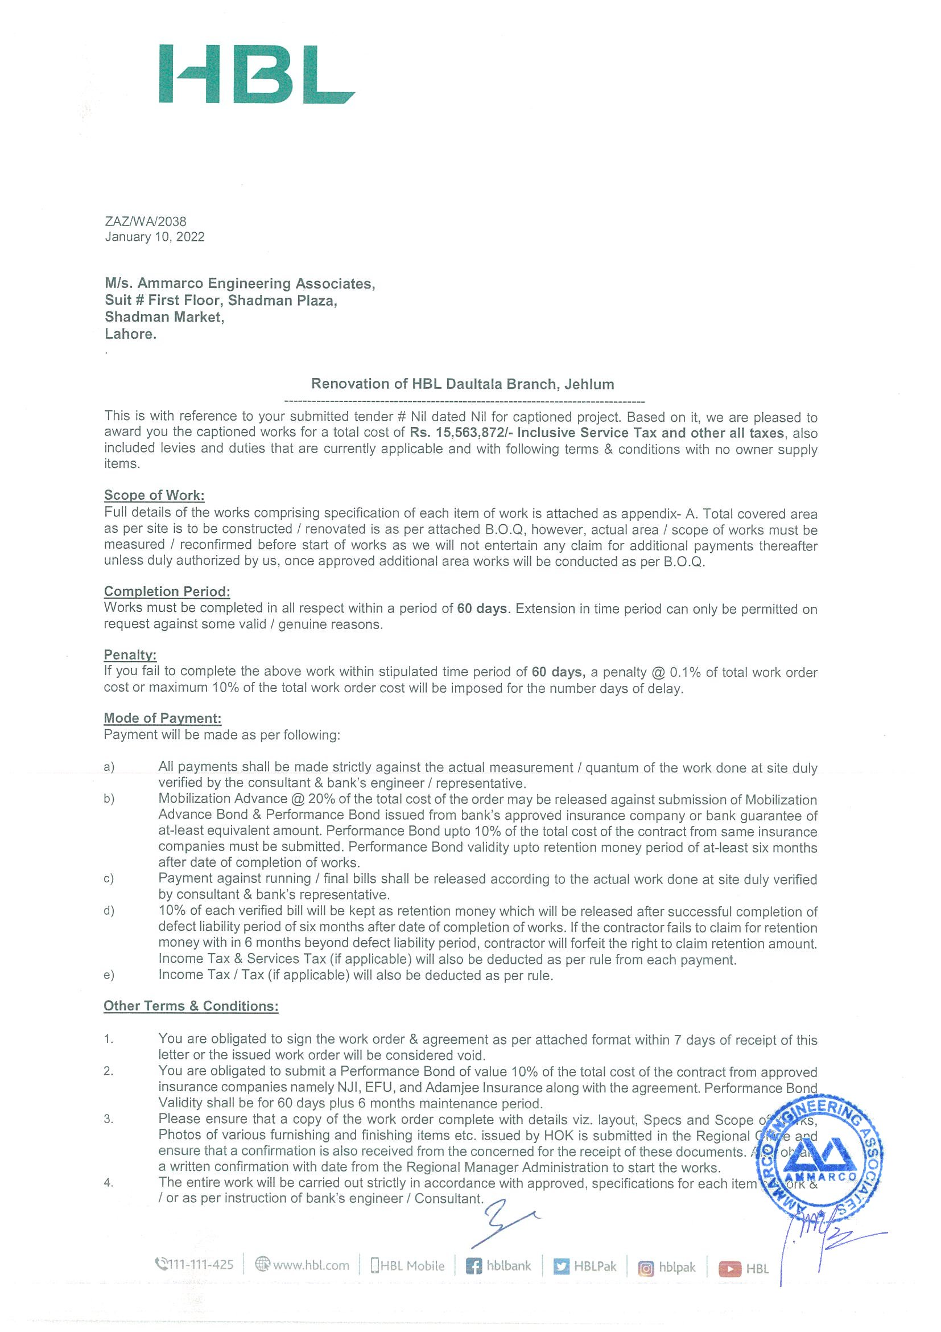
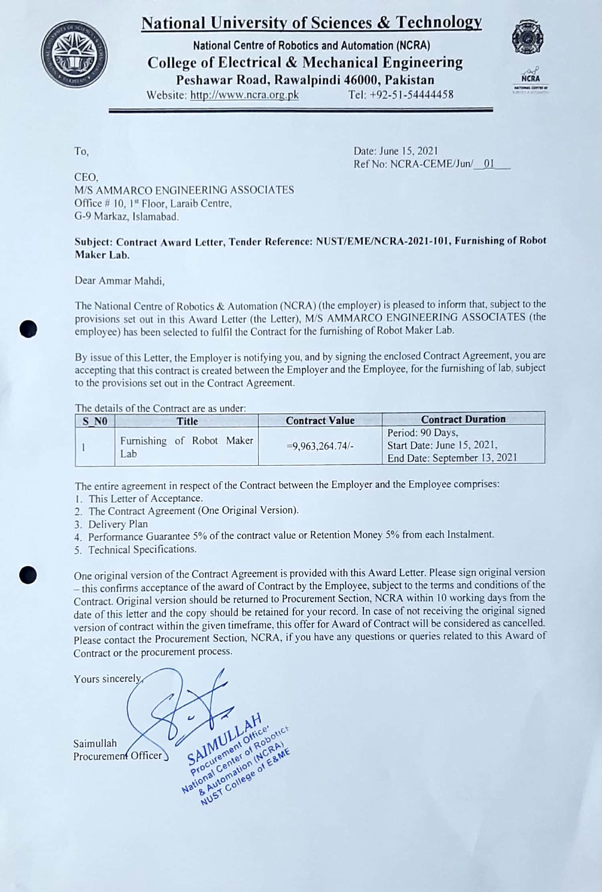
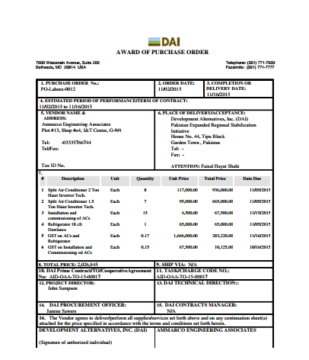

References:

Sr.# | Work Order / Contract Details | Client Name |  | Contact Person | Contact Number | Email
1 | Renovations of Front Line Branches | HBL |  | Maj. Tanveer Sahb | 051-2823082 | tanveer.ahmad@hbl.com
2 | HVAC, Security Cabins,  Anti-Blast Films | DAI (KPG Project) |  | M Ali Shah | 0310-9993346 | Ali_Shah@dai.com
3 | Renovations of IESCO, MEPCO, PESCO, LESCO, FESCO, KESCO Different Offices All Over Pakistan, Fabrication of Ravi Rear Decks (Pick Ups) | USAID |  | Syed Munir Raza Zaidi | 0333-5140877 | Faceimpact.pk1@gmail.com
4 | Fabrication of Factory  Outlet &Display Center | Nakalah Wear® |  | Abbas Kareem CEO | 0321-5175749 | abbaskarim@naklahwear.com

Undertaking:

We, M/s Ammarco Engineering Associates, a firm registered with PEC under the Registration Number: 60357 hereby certify that;
- Our organization is not black listed on any list of sanctioned parties issued by the Pakistan Government, United States Government, European Union and United Nations.
- Our organization was never declared at serious fault of implementation owing to a breach of our contractual obligations.
- Our organization is not involved in and does not support any activity which is considered illegal by the Government of Pakistan or under the International Laws Community or what may be termed as “terrorist activity”

I confirm that the above information is accurate to the best of my knowledge. I have not withheld information.
Name: Ammar Mahdi
Position: C.E.O
Sign & Official Stamp:

Certificate by the supplier:

We underscore the importance of a free, fair and competitive procurement process that precludes fraudulent use. In this respect we have neither offered nor granted, directly or indirectly, any inadmissible advantages to any public servants or other persons in connection with our bid, nor will we offer or grant any such incentives or conditions in the present procurement process or, in the event that we are awarded the contract, in the subsequent execution of the contract. We also underscore the importance of adhering to minimum social standards ("Core Labor Standards") in the implementation of the project. We undertake to comply with the Core Labor Standards ratified by the country of Pakistan. We will inform our staff about their respective obligations and about their obligation to fulfill this declaration of undertaking and to obey the laws of Pakistan.”

Signature: ____________________________

Name of Organization: Ammarco Engineering Associates

Official Seal:

Supplier Information Sheet

1. Legal Status of the applicant organization: PEC Registered C-6

2. NTN of the organization: 4301468-7

Contact Details of the Bidder:

Name of Focal Person: Ammar Mahdi

Phone/Cell Number: +92 333 5766744

Phone Number: +92 051-2325443

E-Mail Address: ammarco.pk@gmail.com

Complete Postal Address: 1st Floor, Office # 10, Laraib Centre, G-9 Markaz, Islamabad.

Signature: ____________________________

Name: Ammar Mahdi

Designation: C.E.O

Official Seal:

